The tutorial has three parts.
- Creating the example scripts from the document “Control Structures in PHP scripts ”
- Answering the theory questions in part two. (some of these will require additional research on the Internet).
- Developing the practical scripts in part three.
This tutorial includes practical and theoretical questions. It will require you to answer some questions based on existing knowledge, discussions with the teacher and research on selected web sites.
If the question is a written answer questions insert some space at the end of the question and include your answer in blue text. If the question requires a PHP script to be created, create the script and save it for later submission.
Part 2 - Theory Questions
- What is the difference between a pre-test loop and a post-test loop?
Pre-test loop will check the condition of a loop before it actually goes into a loop. The codes will run only if the expression is true. While(expression) do{...} is an example of pre-test loop;
Post-test loop will go through to execute a loop first, and then check the condition. In other words, no matter what the condition is, the codes will run at least one times. Do {...} while(expression) is an example of post-test loop;

- Use the Internet to research the term “pseudo code” and answer the following questions.
  - What is pseudocode?
It is not a real programming language. So, pseudocode can not be executed or can not run. Generally, they are “text-based” descriptions of algorithms intended for human reading rather than machine running.
  - Why is it used in computer programming?
The purpose of using pseudocode is to help people to understand key principles of an algorithm. We do not need to read the actual codes, because pseudocode provides a more efficient way to understand what to do.
  - Using an example explain the structure of pseudocode.
IF-ELSE Control Structure
If age > 18
Display a message that you can vote
Else
Display a message that you can not vote

- If we are to properly test the PHP program to ensure it works correctly what aspects do we need to test?
Normally, we use unit test to find out whether a function or method running well. We can greatly reduce or avoid bugs if unit test is used properly.

- Develop the flowchart of the logic required to create the multiplication table in practical questions below.
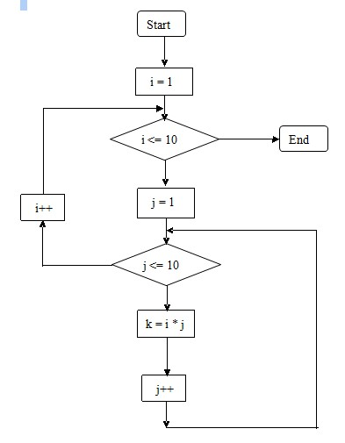

- Develop pseudocode for question 8 but is listed under the practical questions.
BEGIN
a = 3, b = 6;
int i=1;
while(i <= 6) {
if(a > b)
output “A=? and B=?”;
else if(a < b)
output “B=? and A=?”;
i++;
a = a * 3;
b = b * 2;
if(a > 25)
a = a – 10;
if(b > 25)
b = b – 10;
}
END

Part 3- Practical Questions
- Using the elseif control structure write a script that does the following.
  - Creates a single variable that will hold the name of one of three vegetables, carrot, beans, and tomatoes.
  - The script should output on the computer screen a statement about the vegetable that selection statement matches to the vaule that is assigned to the variable.
    - “Carrots are orange”
    - “Beans are green”
    - “Tomatoes are red”
- Solve the same problem it is presented in question 6 but using a switch statement.
- Develop a script that does the following
  - Creates two variables that are both integers, name them A and B and assign A the value of 3 and B the value of 6. (other values will be assigned from later)
  - Display the values of each on the screen in the following format “A = 3 and B = 6” (but the variable holding the biggest number should appear first in the output)
  - Create a loop that will allow these numbers to display six times only.
  - Once the values have been displayed multiply the value in A by three, and the number in B by 2.
  - If the value of either of the two numbers is greater than 25, subtract 10 from the number and continue with the other iterations in the loop.
  - Once the names and their values or numbers have been displayed six times the program should terminate.
- Develop a script that will create the 10 times arithmetic tables that will create an output like that image shown below. (This will require knowledge from the previous semester to build the HTML table)
